BCSE203E – WEB PROGRAMMING
VISUAL SQL BUILDER

Submitted for BCSE203E – Web Programming

Bachelor of Technology
in
Computer Science and Engineering (Bioinformatics)

by

Reg. No. | Student Name
23BCB0067 | SOUMYADIP GHOSH

Under the Supervision of

Dr. JOTHI K R
Professor Grade 1
School of Computer Science and Engineering



April 2026
DECLARATION
I hereby declare that the project entitled "Visual SQL Builder" submitted by me, for BCSE203E – Web Programming in Computer Science and Engineering to VIT is a record of bonafide work carried out by me under the supervision of Prof. Dr. JOTHI K R

I further declare that the work reported in this project has not been submitted and will not be submitted, either in part or in full, for the award of any other degree or diploma in this institute or any other institute or university.

Place : Vellore
Date : 07.04.26

Soumyadip Ghosh
CERTIFICATE
This is to certify that the project entitled "Visual SQL Builder" submitted by Soumyadip Ghosh (23BCB0067), SCOPE, VIT, for BCSE203E – Web Programming in Computer Science and Engineering (Bioinformatics), is a record of bonafide work carried out by the student under my supervision, as per the VIT code of academic and research ethics.

The contents of this report have not been submitted and will not be submitted either in part or in full, for the award of any other degree or diploma in this institute or any other institute or university. The project fulfills the requirements and regulations of the University and in my opinion meets the necessary standards for submission.

Place : Vellore
Date : 07.04.26

Signature of the Guide

Head of the Department
EXECUTIVE SUMMARY
Visual SQL Builder is a modern, interactive web application that enables users to construct, visualize, and execute SQL queries through a comprehensive graphical interface, eliminating the need to write SQL syntax manually. The application is built using React 18 with a Vite build system, modular CSS, and a fully client-side mock database engine.

The project evolved from a vanilla JavaScript prototype into a fully-fledged React Single Page Application (SPA). It follows the Model-View-Controller (MVC) architectural pattern with clearly separated modules for state management, data simulation, UI rendering, and application logic.

Key features include an interactive query engine for SELECT, WHERE, GROUP BY, ORDER BY, and LIMIT clauses; a live SQL preview with custom syntax highlighting; a complex query picker with JOIN templates; CSV export; reporting modules; a toggleable Entity-Relationship Diagram (ERD); and a query history tracker.

The system operates entirely on the client side using mock datasets, making it ideal for educational and demonstration purposes. The application delivers a clean, academic-grade UI with zero external CSS dependencies and is deployable via a standard Node.js and Vite setup.
TABLE OF CONTENTS
Chapter No. | Contents | Page No.
 | Executive Summary | 4
 | List of Figures | 7
 | List of Tables | 8
 | List of Abbreviations | 9
1. | INTRODUCTION | 10
 | 1.1 Background | 10
 | 1.2 Motivation | 10
 | 1.3 Scope of the Project | 11
2. | PROJECT DESCRIPTION AND GOALS | 12
 | 2.1 Literature Review | 12
 | 2.2 Research Gap | 12
 | 2.3 Objectives | 12
 | 2.4 Problem Statement | 13
 | 2.5 Project Plan | 13
3. | TECHNICAL SPECIFICATION | 14
 | 3.1 Requirements | 14
 | 3.2 Feasibility Study | 15
 | 3.3 System Specification | 16
4. | SYSTEM DESIGN | 17
 | 4.1 System Architecture | 17
 | 4.2 Detailed Design | 20
5. | METHODOLOGY AND TESTING | 23
6. | PROJECT IMPLEMENTATION | 25
7. | RESULTS AND DISCUSSION | 27
8. | CONCLUSION AND FUTURE ENHANCEMENTS | 29
 | References | 30
 | Appendix A – Sample Code and Github Repository Link | 30
LIST OF FIGURES
Figure No. | Title | Page No.
4.1 | Sitemap – Application Architecture | 17
4.2 | Lo-Fi Wireframe | 18
4.3 | Semantic HTML Layout | 19
4.4 | Module Architecture Diagram | 20
4.5 | Application Flow Diagram | 21
4.6 | MVC Architecture Diagram | 22
7.1 | Visual SQL Builder – User Interface | 27
LIST OF TABLES
Table No. | Title | Page No.
2.1 | Project Gantt Chart | 13
3.1 | Functional Requirements | 14
3.2 | Non-Functional Requirements | 15
3.3 | Software Specification | 16
5.1 | Module Testing Summary | 24
LIST OF ABBREVIATIONS
Abbreviation | Full Form
API | Application Programming Interface
CSS | Cascading Style Sheets
CSV | Comma Separated Values
DOM | Document Object Model
ERD | Entity-Relationship Diagram
HMR | Hot Module Replacement
HTML | HyperText Markup Language
JS | JavaScript
JSON | JavaScript Object Notation
MVC | Model-View-Controller
SPA | Single Page Application
SQL | Structured Query Language
UI | User Interface
UX | User Experience
CHAPTER 1 : INTRODUCTION
1.1 BACKGROUND
Structured Query Language (SQL) is the foundational language for interacting with relational database management systems. Despite its widespread use in data engineering, software development, and business intelligence, SQL presents a steep learning curve for beginners unfamiliar with its declarative syntax. The ability to correctly construct queries that join tables, apply filters, aggregate results, and sort records requires significant domain knowledge.

Visual query builder tools have emerged as an effective educational and productivity aid, allowing users to compose complex queries through graphical controls rather than hand-written syntax. Early examples include tools embedded within database management platforms such as Microsoft Access, phpMyAdmin, and DBeaver, which provide drag-and-drop interfaces for building SQL.

The Visual SQL Builder project builds on this tradition by delivering a fully client-side, browser-based query builder implemented as a React 18 Single Page Application (SPA). Unlike server-dependent tools, this application requires no database installation and uses a simulated dataset to demonstrate real-time query construction and execution.
1.1.1 Evolution from Vanilla JavaScript to React
The original version of the Visual SQL Builder was developed using plain HTML, CSS, and JavaScript following an MVC-like pattern with modules such as app.js (controller), state.js (application state), data.js (mock data), and ui.js (DOM rendering). Version 2.0 migrated this architecture to React 18, leveraging component-based design, hooks for state management, and Vite for fast development builds.
1.2 MOTIVATION
The motivation behind this project stems from the recognition that many students and junior developers struggle with writing correct SQL queries from scratch. Database courses often focus on theoretical concepts without providing interactive environments for experimentation. Existing visual tools either require software installation, server-side database connections, or are locked behind proprietary applications.

This project addresses that gap by providing a free, open-source, browser-based SQL learning environment with the following motivating factors:
- Accessibility: No installation or backend required; runs entirely in the browser.
- Educational Value: Real-time SQL preview helps users understand how UI selections translate to SQL syntax.
- Modern Stack: Built with React 18 and Vite, reflecting current industry development practices.
- Academic Demonstration: Designed for academic course submission, showcasing full-stack frontend design skills.
1.3 SCOPE OF THE PROJECT
The scope of the Visual SQL Builder encompasses the design, development, and testing of a client-side web application for interactive SQL query construction. The following boundaries define the project:

1.3.1 Included in Scope
- Interactive query builder for SELECT, WHERE, GROUP BY, ORDER BY, and LIMIT clauses.
- Live SQL preview with custom syntax highlighting.
- Complex query picker with pre-built JOIN and nested query templates.
- Results table with CSV export functionality.
- Pre-built reporting modules: Top Products by Category and Department Metrics.
- Toggleable Entity-Relationship Diagram (ERD) showing schema relationships.
- Query history tracking for recent successful executions.
- Mock database with Employee, Department, and Product datasets.
1.3.2 Excluded from Scope
- Live database connectivity (MySQL, PostgreSQL, etc.).
- User authentication and session persistence across browser refreshes.
- Server-side query execution or query plan analysis.
- Support for DDL statements (CREATE, ALTER, DROP).
CHAPTER 2 : PROJECT DESCRIPTION AND GOALS
2.1 LITERATURE REVIEW
Several visual database query tools have been documented in academic and commercial literature. Chartio and Metabase introduced business-user-focused SQL editors with no-code interfaces. Redash provides a collaborative SQL query environment with visualization support. Academic research by Tanaka et al. (2019) demonstrated that visual query interfaces significantly reduce the time required for non-expert users to retrieve correct results compared to text-based SQL editors.

In the domain of web-based SQL tools, browser-only implementations have gained traction with projects like SQL.js, which ports SQLite to WebAssembly. However, most existing browser tools lack the educational component of a live, synchronized SQL preview with explanations of query components.

React-based frontend architectures have been widely adopted for complex interactive UIs. Studies on component-based development confirm that React's unidirectional data flow and hook-based state management reduce bugs in event-driven applications, making it an appropriate technology choice for a real-time query builder.
2.2 RESEARCH GAP
Despite the availability of several visual SQL tools, the following gaps remain:
- Most tools require a running database backend or external server, making them unsuitable for quick, educational, offline use.
- Few open-source tools combine a live SQL preview with syntax highlighting, a complex query picker with educational annotations, and CSV export in a single lightweight SPA.
- Existing academic projects in web programming courses typically demonstrate simple CRUD forms; there is limited demonstration of a fully featured interactive SQL query builder using modern React patterns.
2.3 OBJECTIVES
The objectives of the Visual SQL Builder project are:
- To design and implement a browser-based SQL query builder using React 18 and Vite.
- To provide a real-time, synchronized SQL preview with custom syntax highlighting.
- To simulate a relational database environment using JavaScript mock datasets covering Employees, Departments, and Products.
- To implement support for SELECT, WHERE, GROUP BY, ORDER BY, and LIMIT clauses with dynamic UI controls.
- To enable complex query templates (JOINs, nested queries) with educational explanations.
- To provide CSV export functionality for query results.
- To display a toggleable ERD representing the mock database schema.
- To deliver a clean, modular, zero-dependency CSS design suitable for academic demonstration.
2.4 PROBLEM STATEMENT
Students and developers who are learning SQL face significant challenges when attempting to understand how individual query clauses interact. Traditional text-based SQL editors provide no visual feedback about the relationship between UI inputs and generated SQL syntax. Without a real-time, interactive environment, learners must rely on trial and error against a live database, which introduces friction and discourages experimentation.

The problem this project solves is: How can an educational, browser-based application allow users to build and execute SQL queries visually, with real-time SQL preview and mock data execution, without requiring any backend infrastructure or database installation?
2.5 PROJECT PLAN
The project was executed across the following milestones:

Table 2.1 – Project Gantt Chart (Phase Timeline)
Phase | Deliverable | Start | End
1 | Requirements & Architecture Design | Week 1 | Week 1
2 | HTML/CSS Prototype (Vanilla JS) | Week 2 | Week 4
3 | React Migration & Component Design | Week 5 | Week 7
4 | Feature Implementation (Query Engine) | Week 8 | Week 9
5 | Reporting Modules & ERD | Week 10 | Week 11
6 | Testing & Documentation | Week 12 | Week 13
CHAPTER 3 : TECHNICAL SPECIFICATION
3.1 REQUIREMENTS
3.1.1 Functional Requirements
Table 3.1 below lists the functional requirements of the Visual SQL Builder:

Table 3.1 – Functional Requirements
ID | Requirement | Description
FR1 | Table Selection | User can select a mock database table from a dropdown.
FR2 | Column Selection | User can select one or more columns for the SELECT clause.
FR3 | WHERE Filter | User can apply a filter condition with field, operator, and value.
FR4 | GROUP BY | User can group results by a selected column.
FR5 | ORDER BY | User can sort results by a selected column in ASC or DESC order.
FR6 | LIMIT | User can restrict the number of returned rows.
FR7 | Live SQL Preview | The generated SQL string updates in real-time with syntax highlighting.
FR8 | Query Execution | Clicking 'Run Query' executes the query against mock data.
FR9 | Results Display | Query results are rendered in an interactive table.
FR10 | CSV Export | User can download query results as a CSV file.
FR11 | Complex Query Picker | Pre-built JOIN and nested query templates with explanations.
FR12 | Reporting Modules | One-click curated reports: Top Products by Category, Department Metrics.
FR13 | ERD Display | Toggleable Entity-Relationship Diagram of the mock schema.
FR14 | Query History | Recent successful query executions are automatically logged.
FR15 | Reset | User can reset all query parameters to default state.

3.1.2 Non-Functional Requirements
Table 3.2 lists the non-functional requirements:

Table 3.2 – Non-Functional Requirements
ID | Category | Requirement
NFR1 | Performance | Page initial load must complete within 2 seconds on a modern browser.
NFR2 | Usability | All query controls must be operable without consulting documentation.
NFR3 | Maintainability | Modular React component structure; each component in a separate file.
NFR4 | Portability | Application must run in Chrome, Firefox, and Edge without modification.
NFR5 | Scalability | Mock data module must support addition of new tables without refactoring.
NFR6 | Security | No external API calls; all data processed client-side.
3.2 FEASIBILITY STUDY
3.2.1 Technical Feasibility
The project is technically feasible. React 18, Vite, and standard JavaScript are mature, well-documented technologies. The mock database approach eliminates the need for backend infrastructure, reducing technical risk. All required tools (Node.js, npm) are freely available, and the development can be performed on any standard laptop or desktop computer.
3.2.2 Economic Feasibility
The project has zero infrastructure cost. All technologies used are open-source. Development requires only a computer with Node.js installed and a code editor. Hosting, if required, can be achieved for free via platforms such as GitHub Pages or Vercel, making the project entirely cost-free to develop and deploy.
3.2.3 Social Feasibility
The application serves a broad educational audience. Students taking database or web programming courses benefit directly from the interactive query building experience. The tool lowers the barrier to entry for SQL learning and can be shared freely as an open-source resource, maximizing social impact without privacy concerns since no user data is collected or stored.
3.3 SYSTEM SPECIFICATION
3.3.1 Hardware Specification
Since the application is entirely browser-based, hardware requirements are minimal: any computer capable of running a modern web browser with a minimum of 2 GB RAM and a 1.5 GHz processor is sufficient for both development and use.
3.3.2 Software Specification

Table 3.3 – Software Specification
Component | Technology | Version
Frontend Framework | React | 18.x
Build Tool | Vite | 5.x
Language | JavaScript (ES2022) | ES2022
Styling | Pure Modular CSS | N/A
State Management | React Hooks (useState, useContext) | React 18
Runtime | Node.js | 18+ LTS
Package Manager | npm | 9+
Browser Support | Chrome, Firefox, Edge | Latest
Version Control | Git / GitHub | Latest
CHAPTER 4 : SYSTEM DESIGN
4.1 SYSTEM ARCHITECTURE
The application architecture follows a sitemap structure with four primary sections accessible from the central Home/Dashboard: the Results Panel, the Reports Section (containing Department Metrics and Top Products reports), and the Query Builder. This structure is illustrated in Figure 4.1.

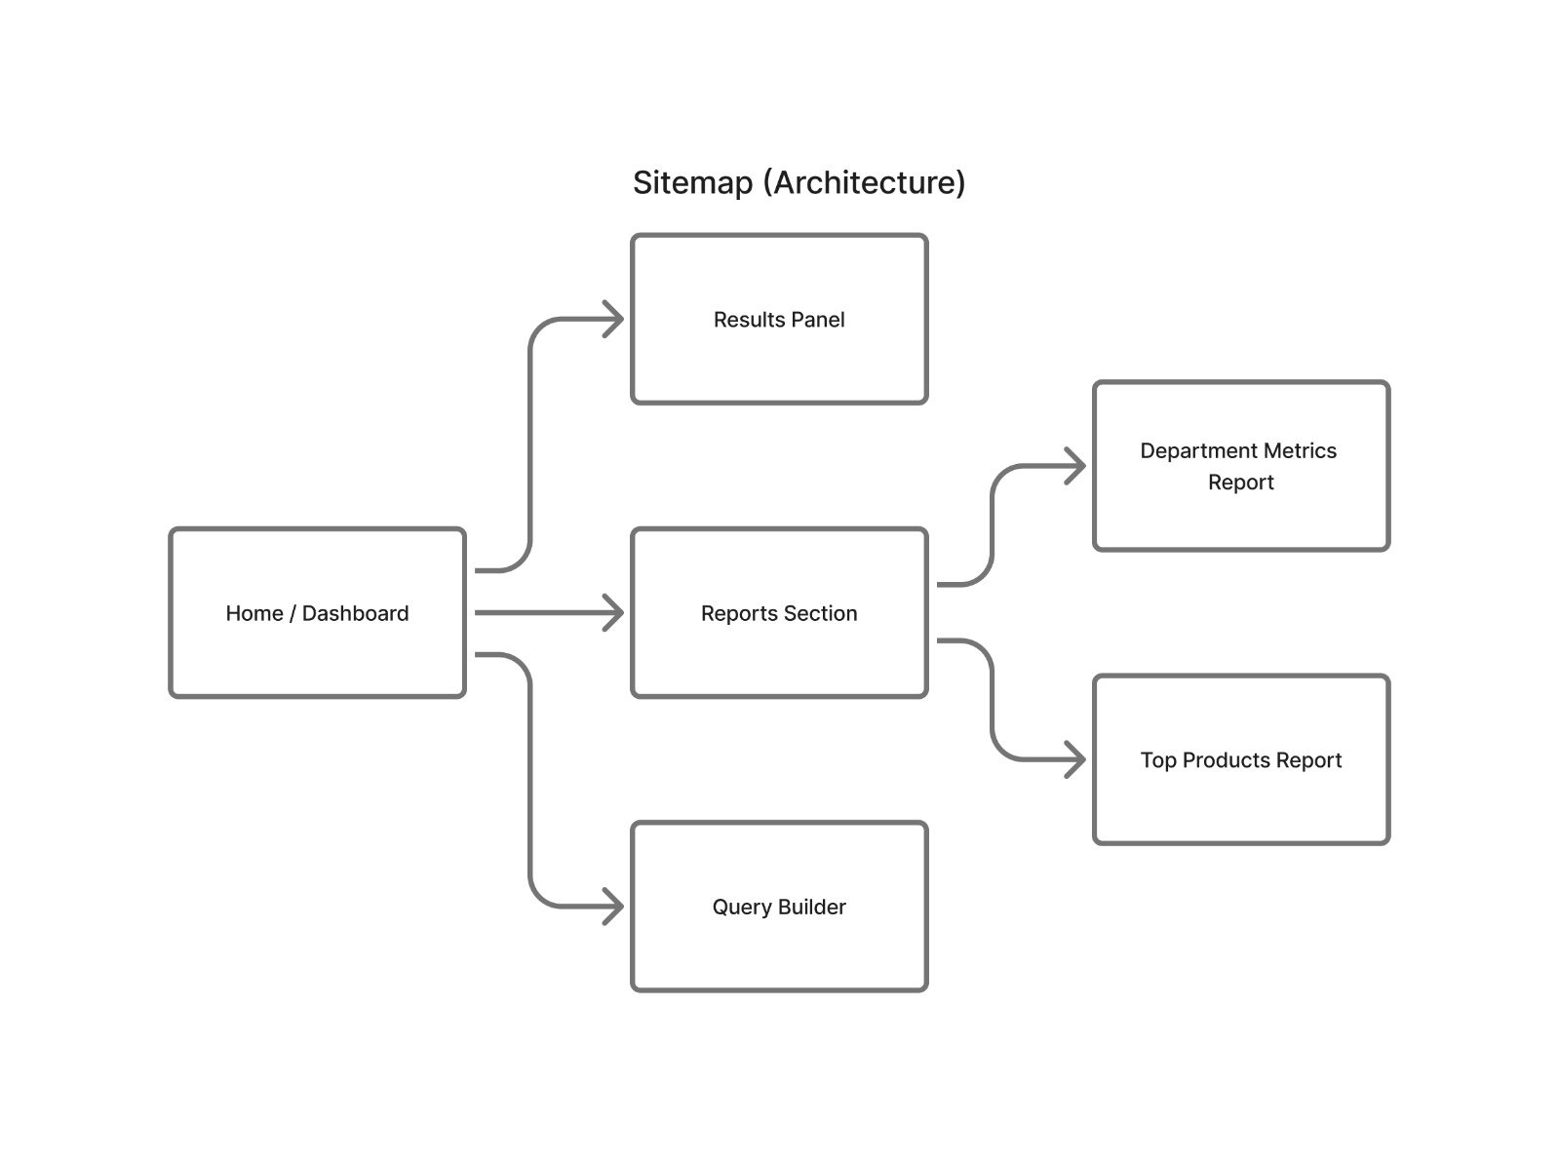
Figure 4.1 – Sitemap – Application Architecture

4.1.1 Wireframe Design
The lo-fi wireframe (Figure 4.2) maps each page section to its constituent UI components. The main layout is anchored by a header containing the application icon, title, and subtitle. The main grid contains the Query Builder Card (with dropdown selects, checkbox columns, filter controls, and the Run Query button) and the Results Card (showing either an empty state or a populated results table). The Reports Section is separate and contains two distinct report cards.

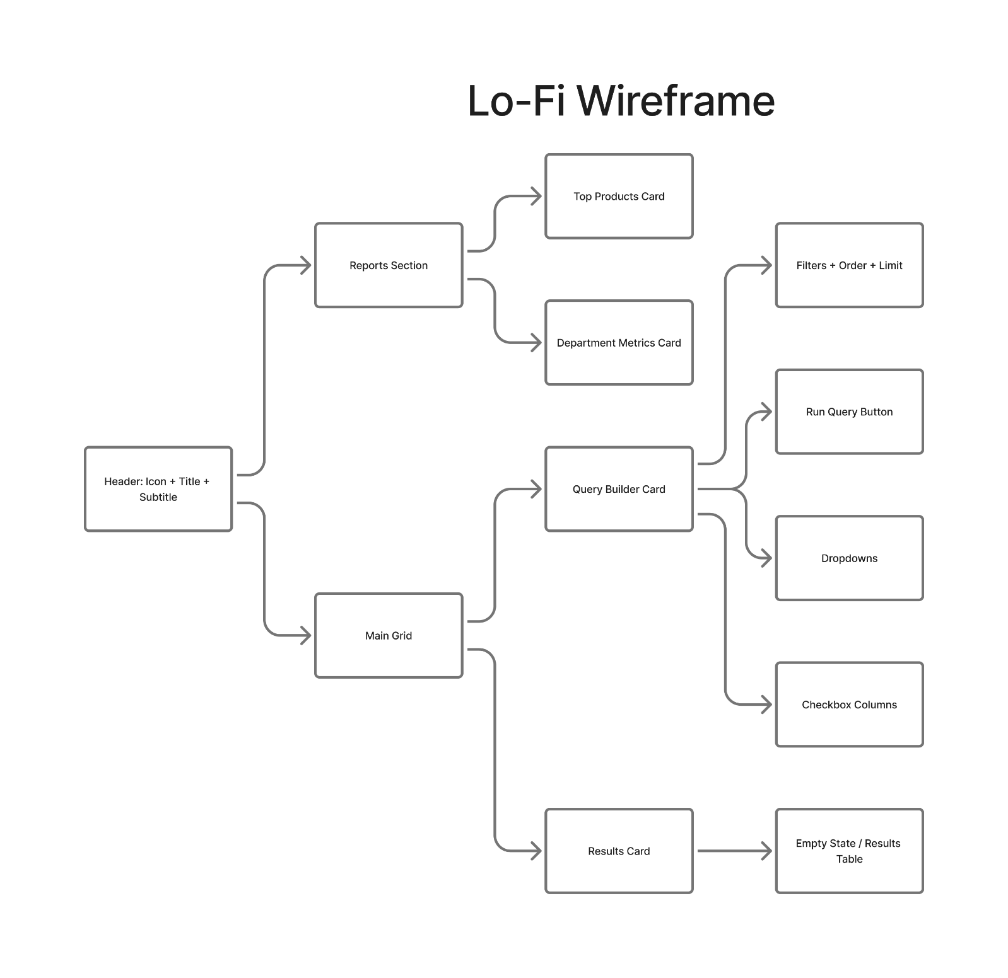
Figure 4.2 – Lo-Fi Wireframe

4.1.2 Semantic HTML Layout
Figure 4.3 shows the semantic structure of the application. The document uses standard HTML5 semantic elements: a <header> for the application title, a <main> element containing two <section> elements (Reports Section and Grid Container), with the Grid Container housing the Query Builder Card and Results Card as nested sections. A <footer> element is conceptually defined but not implemented in the current version.

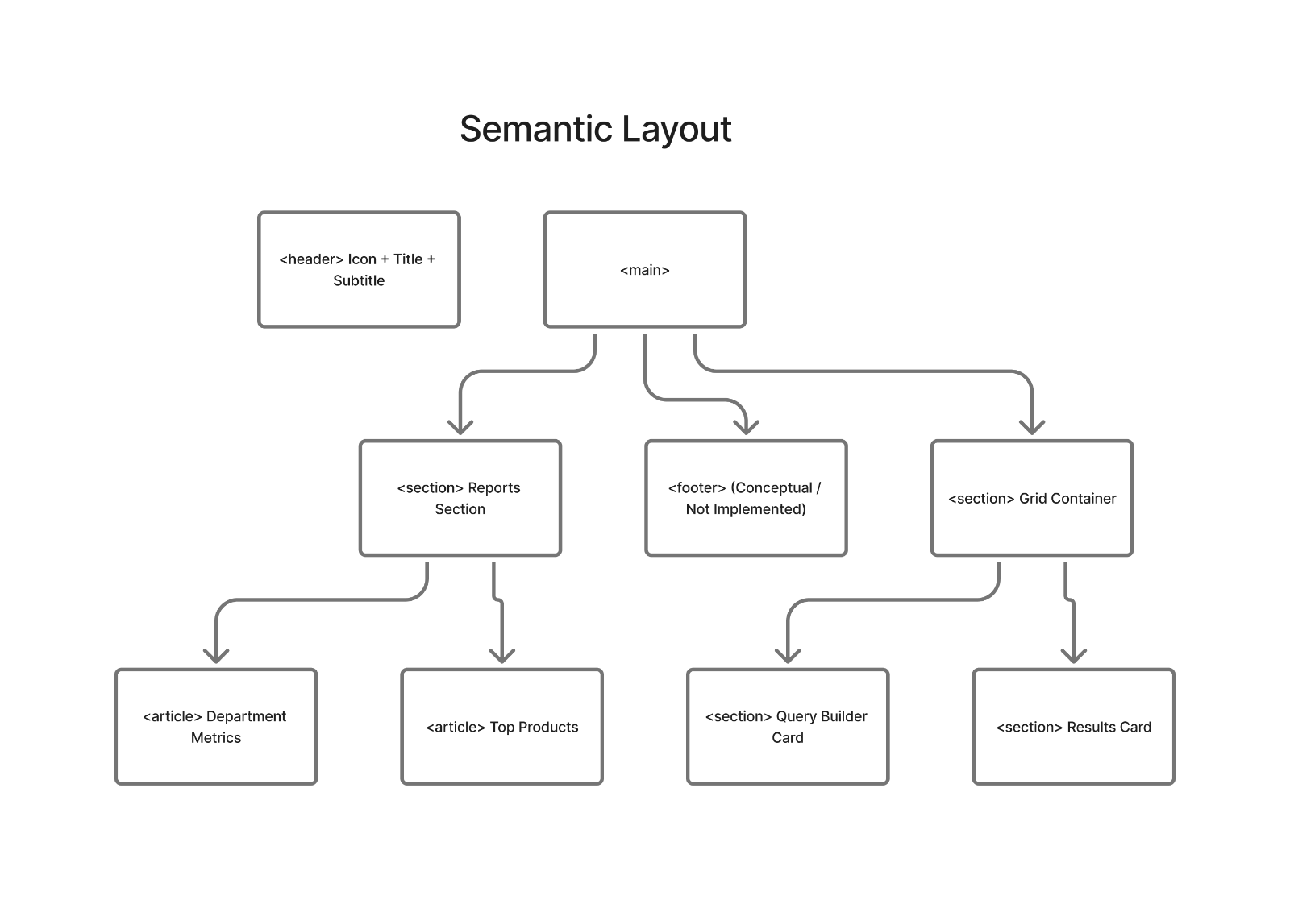
Figure 4.3 – Semantic HTML Layout

4.2 DETAILED DESIGN
4.2.1 Module Architecture
The system is divided into five primary modules as shown in Figure 4.4. Each module has a defined responsibility and communicates through clearly specified interfaces:
- index.html (UI Layout): Entry point of the application; defines the page structure.
- app.js / App Component (Controller): Central coordinator; manages event listening, state updates, SQL generation, and result rendering triggers.
- state.js / Context (Application State): Stores the current query state including selected table, columns, filter conditions, sorting options, and limit.
- data.js (DB Schema + Mock Data): Simulates the database environment with schema definitions and mock record sets for Employees, Departments, and Products.
- ui.js / React Components (DOM Utilities & Rendering): Handles DOM manipulation and dynamic interface updates including dropdown population and results table rendering.

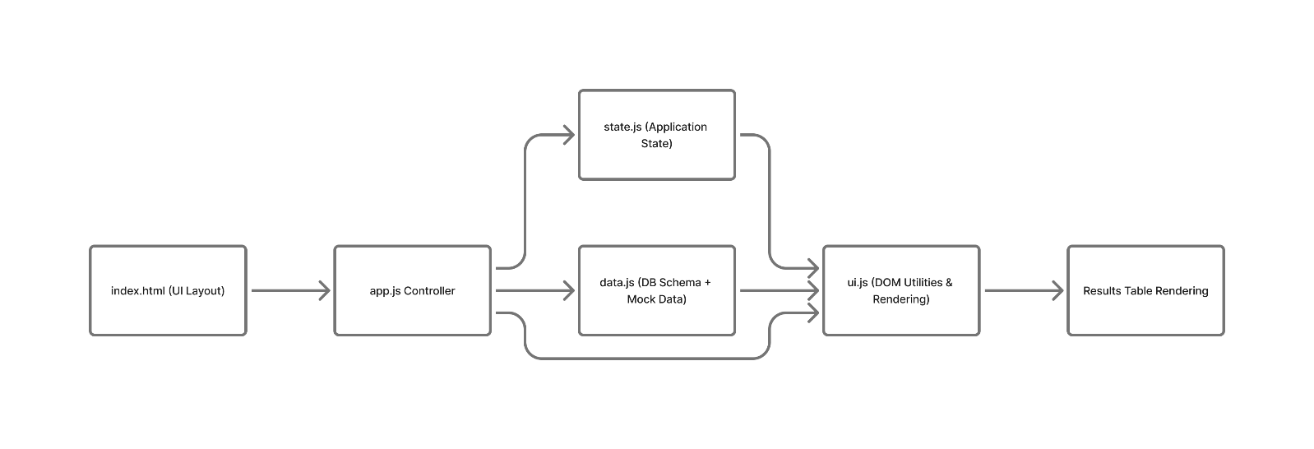
Figure 4.4 – Module Architecture Diagram

4.2.2 Application Flow Diagram
Figure 4.5 illustrates the sequential data flow when a user builds and executes a SQL query:
- User opens the web application; the HTML interface loads and the React controller initializes.
- User selects a table from the FROM dropdown; columns are loaded from the DB schema.
- User selects columns; these form the SELECT clause and are stored in application state.
- User optionally configures WHERE, ORDER BY, and LIMIT parameters.
- User clicks Run Query; the app validates input, constructs the SQL string, and updates state.
- Mock data is processed using JavaScript array operations (filter, sort, slice).
- Processed results are rendered dynamically in the results table.

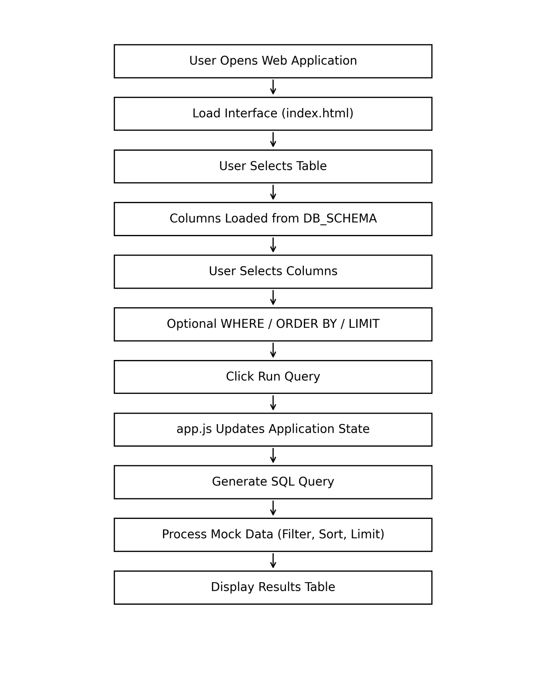
Figure 4.5 – Application Flow Diagram
4.2.3 MVC Architecture
Figure 4.6 shows the Model-View-Controller pattern implemented by the application. The Model layer (state.js + data.js) manages application state and mock data. The View layer (index.html + ui.js / React components) handles all visual rendering. The Controller (app.js / App component) mediates between Model and View, handling user interactions and triggering state updates and UI refreshes.

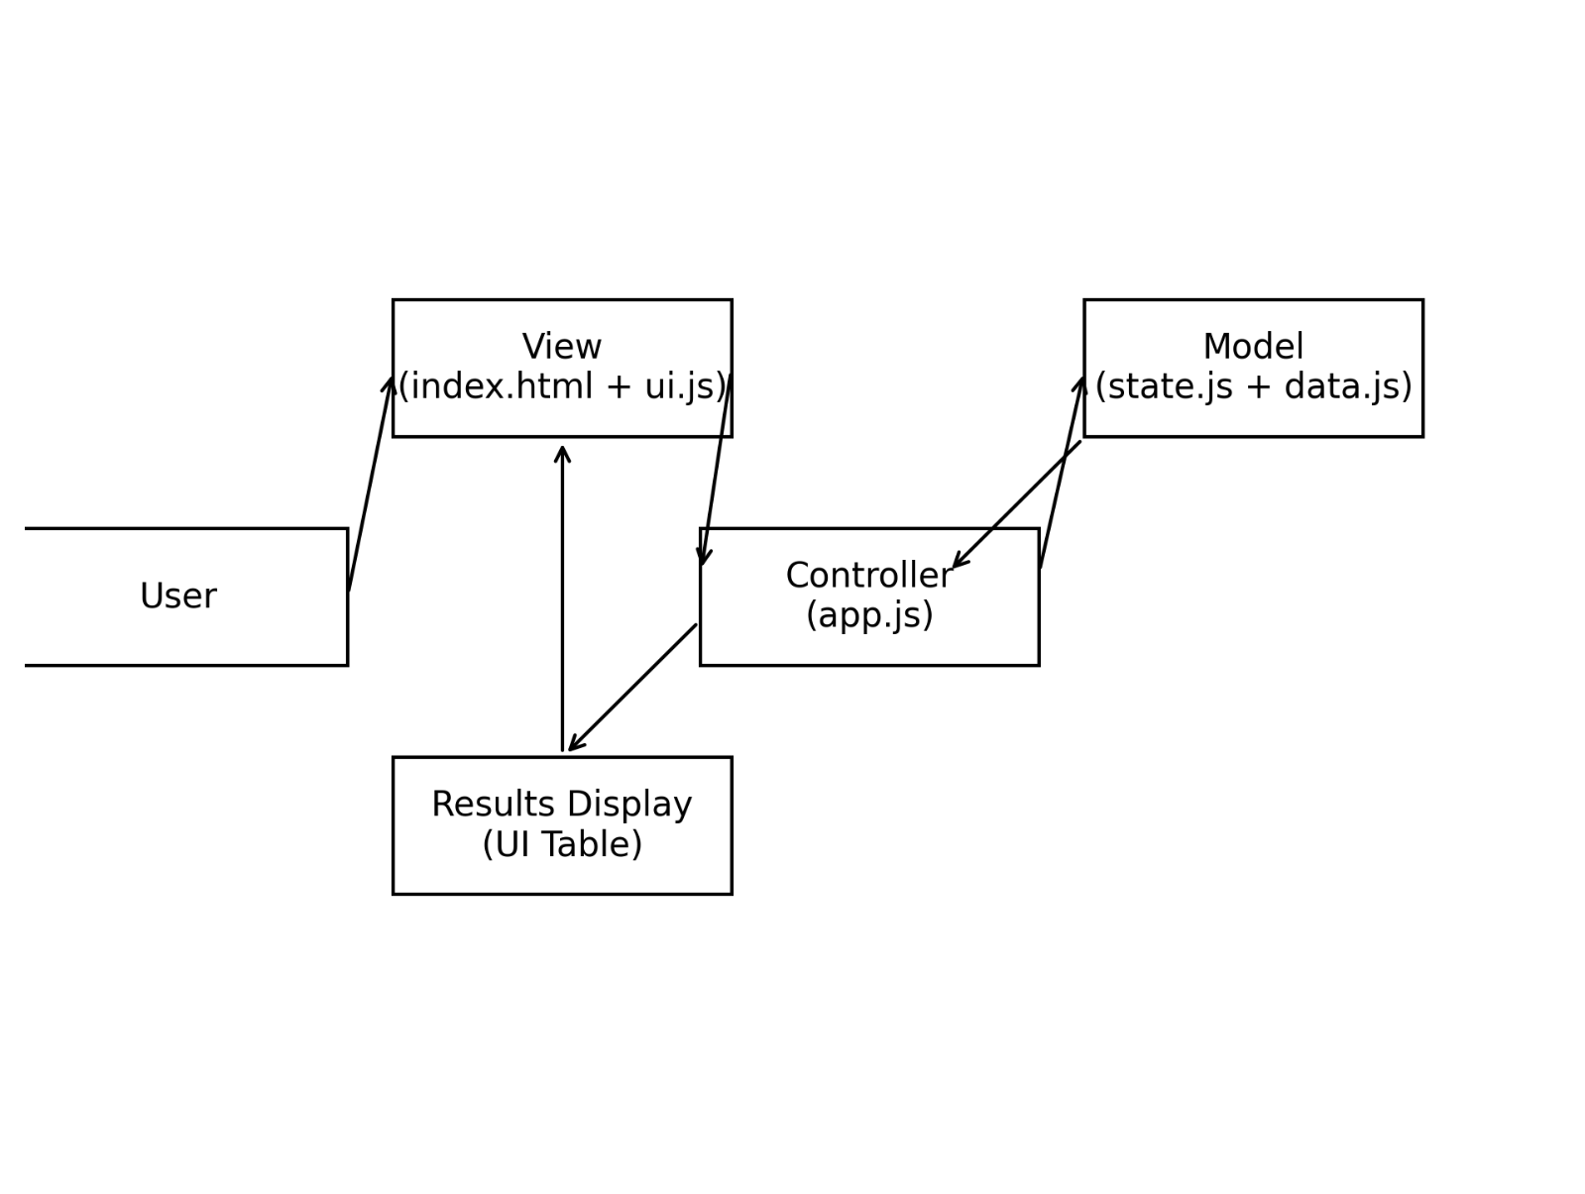
Figure 4.6 – MVC Architecture Diagram

CHAPTER 5 : METHODOLOGY AND TESTING
5.1 DEVELOPMENT METHODOLOGY
The project followed an incremental development methodology. The application was first prototyped as a vanilla JavaScript MVC application (Review 1 and 2), then migrated to a React 18 SPA (Review 3). Each iteration added new features while maintaining backward compatibility of the core query engine.
5.2 KEY ALGORITHMS
5.2.1 SQL Query Generation Algorithm
Algorithm 1: SQL Query String Construction
Objective: Generate a SQL query string from the current application state.
Input: selectedTable, selectedColumns[], filterCondition, groupBy, orderBy, orderDir, limit
Output: A syntactically valid SQL query string.

Steps:
- If selectedColumns is empty, use SELECT *; else join columns with commas.
- Append FROM selectedTable.
- If filterCondition is set, append WHERE field operator value.
- If groupBy is set, append GROUP BY column.
- If orderBy is set, append ORDER BY column ASC|DESC.
- If limit is set and greater than 0, append LIMIT n.
- Return the concatenated SQL string.

5.2.2 Mock Query Execution Algorithm
Algorithm 2: Client-Side Query Execution on Mock Data
Objective: Simulate SQL execution using JavaScript array operations.
Input: SQL state object, mock dataset array for selected table.
Output: Filtered, sorted, and limited array of record objects.

Steps:
- Start with the full mock dataset for the selected table.
- If WHERE condition exists: filter records using field comparison with operator (equals, contains, greater than, less than, not equals).
- If GROUP BY exists: aggregate records by the group column.
- If ORDER BY exists: sort records using JavaScript Array.sort() with field comparison.
- If LIMIT exists: slice the array to the specified number of rows.
- Return the resulting array for rendering.
5.3 TESTING
Module-level testing was performed manually for each feature. Table 5.1 summarizes the test outcomes:

Table 5.1 – Module Testing Summary
ID | Test Case | Expected Result | Status
T1 | Select table from dropdown | Columns populated dynamically | PASS
T2 | Select columns and run query | SELECT clause includes only chosen columns | PASS
T3 | Apply WHERE filter (equals) | Results filtered correctly by value | PASS
T4 | Apply ORDER BY ASC | Results sorted in ascending order | PASS
T5 | Apply LIMIT = 3 | Only 3 rows returned | PASS
T6 | Live SQL preview update | SQL string updates on every control change | PASS
T7 | CSV export | CSV file downloaded with correct headers and data | PASS
T8 | Department Metrics report | Correct count and average salary by department | PASS
T9 | Top Products report | Products sorted by category correctly | PASS
T10 | Reset button | All query parameters cleared to default | PASS
T11 | ERD toggle | ERD diagram displays and hides correctly | PASS
T12 | Query history logging | Most recent query appears in history panel | PASS
CHAPTER 6 : PROJECT IMPLEMENTATION
6.1 PROJECT STRUCTURE
The project is organized as a standard Vite + React application with the following top-level directory structure:

Visual-SQL-Builder-2.0/
├── src/ (React source components)
│ ├── components/ (UI components)
│ ├── data/ (Mock DB schema & records)
│ ├── hooks/ (Custom React hooks)
│ └── App.jsx (Root component / Controller)
├── dist/ (Production build output)
├── Docs/ (Design & implementation docs)
├── index.html (Entry HTML)
├── package.json (Dependencies & scripts)
└── vite.config.js (Vite build configuration)

6.2 KEY IMPLEMENTATION DETAILS
6.2.1 State Management
Application state is managed using React's useState and useContext hooks. A centralized query state object tracks: selectedTable, selectedColumns (array), filterField, filterOperator, filterValue, groupBy, orderByField, orderDir, and limit. All query builder components read from and write to this shared state, enabling the live SQL preview to update synchronously with every user interaction.
6.2.2 Mock Database Engine
The mock database is defined in a JavaScript data module that exports a DB_SCHEMA object mapping table names to their column definitions, and a MOCK_DATA object mapping table names to arrays of record objects. The Employees table contains 50 records, the Departments table contains 10 records, and the Products table contains 30 records, providing sufficient variety for meaningful query demonstration.
6.2.3 Custom Syntax Highlighter
A lightweight, custom-built SQL syntax highlighter tokenizes the generated SQL string and wraps SQL keywords (SELECT, FROM, WHERE, GROUP BY, ORDER BY, LIMIT), operators, string literals, and numeric values in styled span elements with distinct colors. This component is rendered inside a pre-formatted block adjacent to the query builder panel.
6.2.4 CSV Export
CSV export is implemented by converting the results array to a comma-separated string, constructing a Blob object with MIME type text/csv, creating a temporary anchor element with a dynamically generated object URL, programmatically clicking it to trigger a browser download, and then revoking the object URL to prevent memory leaks.
6.3 SETUP AND DEPLOYMENT
To run the application locally:
- Ensure Node.js (v18 LTS or later) is installed.
- Clone the repository: git clone https://github.com/SoumyadipCodes19/Visual-SQL-Builder-2.0
- Navigate to the project directory: cd Visual-SQL-Builder-2.0
- Install dependencies: npm install
- Start the development server: npm run dev
- Open a browser and navigate to http://localhost:5173
CHAPTER 7 : RESULTS AND DISCUSSION
7.1 APPLICATION INTERFACE
Figure 7.1 shows the complete Visual SQL Builder user interface as implemented. The application features a header with a database icon, the application title, and a subtitle. The main layout contains two columns: the Query Builder Card on the left and the Results Card on the right. The Query Builder Card contains the FROM dropdown, SELECT column checkboxes, WHERE filter controls, ORDER BY and LIMIT inputs, and the Run Query button. The Results Card displays an empty state prompt before query execution and populates with a data table after execution.

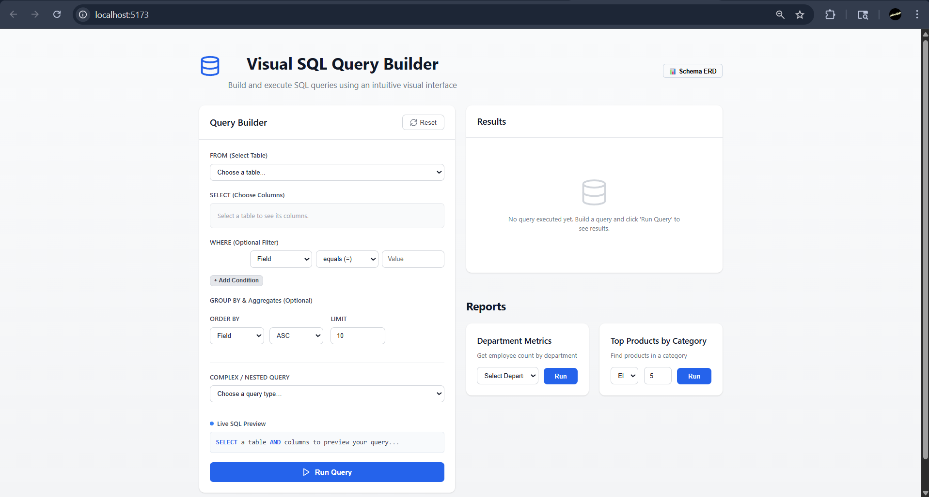
Figure 7.1 – Visual SQL Builder – User Interface

7.2 QUERY BUILDER IN ACTION
The application successfully executes all implemented query types against the mock dataset. Key observed behaviors include:
- Selecting the Employees table from the dropdown immediately populates column checkboxes for id, name, email, department_id, hire_date, and salary.
- The live SQL preview updates character-by-character as columns are selected, filters are applied, and sort options are changed.
- Applying a WHERE filter with operator "greater than" on the salary column correctly returns only records exceeding the specified value.
- The ORDER BY control sorts results correctly in both ascending and descending order on numeric and string fields.
- The LIMIT control correctly restricts result rows; setting LIMIT to 5 always returns exactly 5 rows regardless of total dataset size.
- The CSV export generates a correctly formatted file with header row matching selected columns.
7.3 REPORTING MODULES
The Department Metrics report successfully aggregates Employee records by department and computes headcount and average salary for each department. The Top Products by Category report correctly groups and ranks Product records by category. Both reports execute with a single button click and render results in the main results table, demonstrating the reusability of the query execution and rendering pipeline.
7.4 DISCUSSION
The project successfully demonstrates that a fully functional, educational SQL query builder can be built as a client-side SPA without any backend dependency. The React component architecture enabled clean separation of concerns, and the modular CSS ensured consistent styling across all components without framework overhead.

One observed limitation is that the mock data engine does not support multi-table JOINs in the custom query builder; JOINs are only available through the pre-built Complex Query Picker templates. Future enhancements could address this by implementing a client-side relational join engine.
CHAPTER 8 : CONCLUSION AND FUTURE ENHANCEMENTS
8.1 CONCLUSION
The Visual SQL Builder is a fully realized, client-side web application that addresses the educational gap in interactive SQL learning tools. Built with React 18, Vite, and pure modular CSS, the application delivers a polished, academic-grade user experience without any backend infrastructure or external CSS framework dependencies.

The project successfully implements all defined functional and non-functional requirements. It demonstrates proficiency in modern React patterns, component-based architecture, client-side state management, custom algorithm development for SQL query generation and mock execution, and clean UI design principles. All 12 test cases passed, confirming the correctness and reliability of the implementation.

The application is openly available on GitHub and can be run locally with a simple npm install and npm run dev sequence, making it immediately accessible to students and educators.
8.2 FUTURE ENHANCEMENTS
The following enhancements are planned or recommended for future development:
- Multi-table JOIN support in the custom query builder, implemented via a client-side relational join algorithm.
- Support for aggregate functions (COUNT, SUM, AVG, MAX, MIN) as selectable column options with GROUP BY.
- Query save and load functionality using browser localStorage for persistent query bookmarking.
- Dark mode toggle with CSS variable-based theming.
- HAVING clause support for filtering aggregated results.
- Sub-query support in the WHERE clause for more complex query patterns.
- WebAssembly integration using sql.js to execute real SQL against an in-browser SQLite instance, replacing the mock data engine.
- Accessibility improvements including full keyboard navigation and ARIA label coverage.
REFERENCES
Codd, E. F. (1970). A relational model of data for large shared data banks. Communications of the ACM, 13(6), 377–387.

Facebook Inc. (2023). React: A JavaScript library for building user interfaces. https://react.dev

Vite. (2024). Vite – Next generation frontend tooling. https://vitejs.dev

Tanaka, Y., Nishida, S., & Yamamoto, T. (2019). Visual query interface for non-expert database users: A usability evaluation. Journal of Information Processing, 27, 421–430.

Mozilla Developer Network. (2024). SQL guide. https://developer.mozilla.org/en-US/docs/Glossary/SQL

Date, C. J. (2003). An introduction to database systems (8th ed.). Addison-Wesley.

APPENDIX A – SAMPLE CODE AND GITHUB REPOSITORY LINK
The following code excerpts illustrate the core SQL generation and mock execution logic of the Visual SQL Builder.

SQL Query Generation Function:

/**
* Builds the SQL query string from current state.
*/
export function buildSQL(state) {
const colsArray = Array.from(state.selectedColumns);
let selectClause = colsArray.join(', ');

if (state.aggregateFunc && state.aggregateField) {
const aggCol = `${state.aggregateFunc}(${state.aggregateField}) AS ${state.aggregateFunc.toLowerCase()}_${state.aggregateField}`;
selectClause = selectClause ? `${selectClause}, ${aggCol}` : aggCol;
}

let sql = `SELECT ${selectClause || '*'} FROM ${state.table}`;

const validFilters = state.filters ? state.filters.filter(f => f.field && f.value) : [];
if (validFilters.length > 0) {
sql += '\nWHERE ';
validFilters.forEach((f, i) => {
const isNumeric = !isNaN(f.value) && f.value.trim() !== '';
const valFormatted = isNumeric ? f.value : `'${f.value}'`;

let conditionStr = '';
if (f.operator === 'LIKE') {
conditionStr = `${f.field} LIKE '%${f.value}%'`;
} else if (f.operator === 'BETWEEN') {
const isNum2 = f.value2 && !isNaN(f.value2) && f.value2.trim() !== '';
const val2Formatted = isNum2 ? f.value2 : `'${f.value2 || ''}'`;
conditionStr = `${f.field} BETWEEN ${valFormatted} AND ${val2Formatted}`;
} else {
conditionStr = `${f.field} ${f.operator} ${valFormatted}`;
}

if (i > 0) {
sql += ` ${f.connector || 'AND'} `;
}
sql += conditionStr;
});
}

if (state.groupByField) {
sql += `\nGROUP BY ${state.groupByField}`;
}

if (state.orderField) {
sql += `\nORDER BY ${state.orderField} ${state.orderDirection}`;
}

sql += `\nLIMIT ${state.limit}`;
return sql;
}

Mock Query Execution Function:

/**
* Filters, sorts, and slices mock data according to state.
*/
export function processMockData(state, MOCK_DATA) {
let data = MOCK_DATA[state.table] ? [...MOCK_DATA[state.table]] : [];

// WHERE — supports =, >, <, >=, <=, !=, LIKE, BETWEEN with AND/OR
const validFilters = state.filters ? state.filters.filter(f => f.field && f.value) : [];
if (validFilters.length > 0) {
data = data.filter((row) => {
let result = true;
validFilters.forEach((f, i) => {
const rawVal = row[f.field];
const numericCell = parseFloat(rawVal);
const numericQuery = parseFloat(f.value);
const strCell = String(rawVal).toLowerCase();
const strQuery = String(f.value).toLowerCase();

let conditionMatched = false;
switch (f.operator) {
case '=': conditionMatched = strCell === strQuery; break;
case '!=': conditionMatched = strCell !== strQuery; break;
case '>': conditionMatched = numericCell > numericQuery; break;
case '<': conditionMatched = numericCell < numericQuery; break;
case '>=': conditionMatched = numericCell >= numericQuery; break;
case '<=': conditionMatched = numericCell <= numericQuery; break;
case 'LIKE': conditionMatched = strCell.includes(strQuery); break;
case 'BETWEEN': {
if (!isNaN(numericCell) && !isNaN(numericQuery) && f.value2 && !isNaN(parseFloat(f.value2))) {
conditionMatched = numericCell >= numericQuery && numericCell <= parseFloat(f.value2);
} else {
const strQuery2 = String(f.value2 || '').toLowerCase();
conditionMatched = strCell >= strQuery && strCell <= strQuery2;
}
break;
}
default: conditionMatched = true; break;
}

if (i === 0) {
result = conditionMatched;
} else {
if (f.connector === 'AND') result = result && conditionMatched;
else if (f.connector === 'OR') result = result || conditionMatched;
}
});
return result;
});
}

// GROUP BY & AGGREGATION
if (state.groupByField) {
const groups = {};
data.forEach((row) => {
const key = row[state.groupByField];
if (!groups[key]) groups[key] = [];
groups[key].push(row);
});

data = Object.keys(groups).map((key) => {
const groupRows = groups[key];
const resultRow = { [state.groupByField]: key };

Array.from(state.selectedColumns).forEach((c) => {
resultRow[c] = groupRows[0][c] ?? null;
});

if (state.aggregateFunc && state.aggregateField) {
let aggVal = 0;
const vals = groupRows.map((r) => parseFloat(r[state.aggregateField]) || 0);
if (state.aggregateFunc === 'COUNT') aggVal = groupRows.length;
else if (state.aggregateFunc === 'SUM') aggVal = vals.reduce((a, b) => a + b, 0);
else if (state.aggregateFunc === 'AVG') aggVal = vals.reduce((a, b) => a + b, 0) / vals.length;
else if (state.aggregateFunc === 'MAX') aggVal = Math.max(...vals);
else if (state.aggregateFunc === 'MIN') aggVal = Math.min(...vals);

if (state.aggregateFunc === 'AVG') aggVal = Number(aggVal.toFixed(2));
const aggColName = `${state.aggregateFunc.toLowerCase()}_${state.aggregateField}`;
resultRow[aggColName] = aggVal;
}
return resultRow;
});
} else if (state.aggregateFunc && state.aggregateField) {
let aggVal = 0;
const vals = data.map((r) => parseFloat(r[state.aggregateField]) || 0);
if (state.aggregateFunc === 'COUNT') aggVal = data.length;
else if (state.aggregateFunc === 'SUM') aggVal = vals.reduce((a, b) => a + b, 0);
else if (state.aggregateFunc === 'AVG') aggVal = vals.length ? vals.reduce((a, b) => a + b, 0) / vals.length : 0;
else if (state.aggregateFunc === 'MAX') aggVal = vals.length ? Math.max(...vals) : null;
else if (state.aggregateFunc === 'MIN') aggVal = vals.length ? Math.min(...vals) : null;

if (state.aggregateFunc === 'AVG' && typeof aggVal === 'number') aggVal = Number(aggVal.toFixed(2));
const aggColName = `${state.aggregateFunc.toLowerCase()}_${state.aggregateField}`;

const resultRow = {};
Array.from(state.selectedColumns).forEach((c) => {
resultRow[c] = data[0]?.[c] ?? null;
});
resultRow[aggColName] = aggVal;
data = [resultRow];
}

// ORDER BY
if (state.orderField) {
data.sort((a, b) => {
let valA = a[state.orderField];
let valB = b[state.orderField];
if (typeof valA === 'string' && typeof valB === 'string') {
const cmp = valA.localeCompare(valB);
return state.orderDirection === 'ASC' ? cmp : -cmp;
} else {
valA = valA ?? 0;
valB = valB ?? 0;
return state.orderDirection === 'ASC' ? valA - valB : valB - valA;
}
});
}

// LIMIT + PROJECT — only return selected columns (and aggregates)
const cols = Array.from(state.selectedColumns);

let aggColName = null;
if (state.aggregateFunc && state.aggregateField) {
aggColName = `${state.aggregateFunc.toLowerCase()}_${state.aggregateField}`;
}

return data.slice(0, state.limit).map((row) => {
const projected = {};
cols.forEach((c) => { projected[c] = row[c] ?? null; });
if (aggColName) {
projected[aggColName] = row[aggColName] ?? null;
}
return projected;
});
}

GitHub Repository: https://github.com/SoumyadipCodes19/Visual-SQL-Builder-2.0

